Data Flow Testing

What is Data Flow Testing
# Source: AI Source: Provided by: [Data Path: Persons Table -> ID Column: 1, Name_En Column: Motasem Essam] -> From: [ChatGPT] on [8/24/2025]
Data Flow Testing is a white-box testing technique that focuses on the life cycle of variables within a program — i.e., how they are defined, used, and killed (no longer needed).
Instead of just testing paths or decisions, it specifically checks how data moves through the code and whether variables are used correctly.

🔑 Key Concepts in Data Flow Testing:
# Source: AI Source: Provided by: [Data Path: Persons Table -> ID Column: 1, Name_En Column: Motasem Essam] -> From: [ChatGPT] on [8/24/2025]
- Definition (def): When a variable is assigned a value.
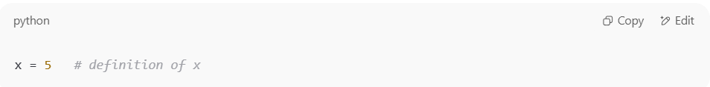
x = 5 # definition of x

- Use (use): When a variable’s value is used.
- Computational use (c-use): in calculations or expressions.
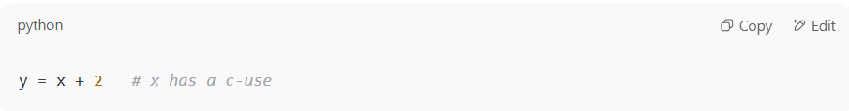
y = x + 2 # x has a c-use

Predicate use (p-use): in decision-making.
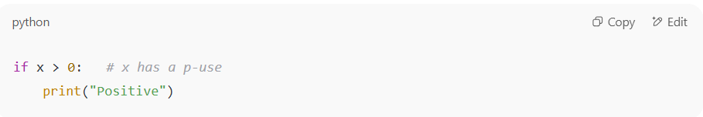
if x > 0: # x has a p-use
print("Positive")

- Kill (or undef): When a variable goes out of scope or is no longer used.

🔍 Example:
# Source: AI Source: Provided by: [Data Path: Persons Table -> ID Column: 1, Name_En Column: Motasem Essam] -> From: [ChatGPT] on [8/24/2025]
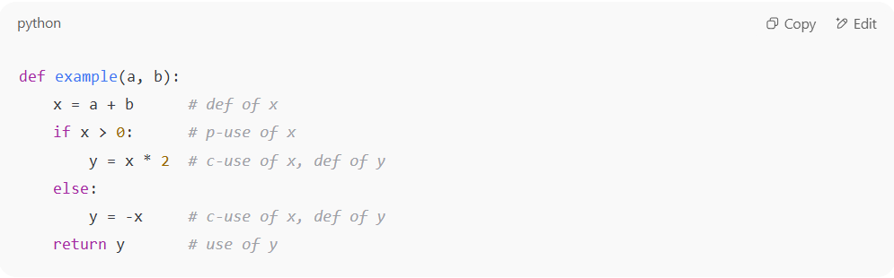
def example(a, b):
x = a + b # def of x
if x > 0: # p-use of x
y = x * 2 # c-use of x, def of y
else:
y = -x # c-use of x, def of y
return y # use of y

- x is defined, then used in a condition (p-use), then in calculations (c-use).
- y is defined in both branches and later used in the return.
👉 Data Flow Testing would check for things like:
- Is x always defined before use?
- Is y used after it is defined in all paths?
- Any variable defined but never used?

✅ Goals of Data Flow Testing:
# Source: AI Source: Provided by: [Data Path: Persons Table -> ID Column: 1, Name_En Column: Motasem Essam] -> From: [ChatGPT] on [8/24/2025]
- Detect anomalies such as:
  - Defined but not used (unused variable)
  - Used but not defined (garbage value / runtime error)
  - Defined multiple times without use in between (redundant assignment)

⚖️ Advantages:
# Source: AI Source: Provided by: [Data Path: Persons Table -> ID Column: 1, Name_En Column: Motasem Essam] -> From: [ChatGPT] on [8/24/2025]
- Finds subtle bugs related to variable misuse that path or branch testing may miss.
- Helps ensure data correctness in addition to control correctness.

⚠️ Limitations:
# Source: AI Source: Provided by: [Data Path: Persons Table -> ID Column: 1, Name_En Column: Motasem Essam] -> From: [ChatGPT] on [8/24/2025]
- More complex analysis than simple coverage methods.
- Can still face combinatorial explosion in large programs.

✅ In short:
Data Flow Testing = testing the flow of data (variables) in the program to ensure they’re properly defined, used, and killed. It’s like tracing variables’ lifecycles to catch logical mistakes.

